Label Encoding

Definition
# Source: AI Source: Provided by: [Data Path: Persons Table -> ID Column: 1, Name_En Column: Motasem Essam] -> From: [Chatgpt (GPT‑5 Mini)] on [12/10/2025]
Label Encoding is a technique used to convert categorical data into numerical values by assigning a unique integer (number) to each category. It is commonly used in data preprocessing for machine learning.

Key Idea
# Source: AI Source: Provided by: [Data Path: Persons Table -> ID Column: 1, Name_En Column: Motasem Essam] -> From: [Chatgpt (GPT‑5 Mini)] on [12/10/2025]
Each distinct category is replaced with a unique number so that machine learning algorithms can process the data.
Example:
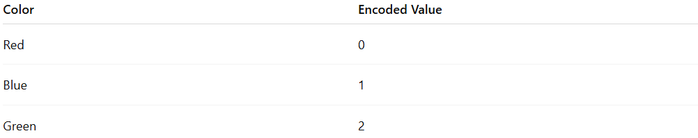
Color | Encoded Value
Red | 0
Blue | 1
Green | 2

How It Works
# Source: AI Source: Provided by: [Data Path: Persons Table -> ID Column: 1, Name_En Column: Motasem Essam] -> From: [Chatgpt (GPT‑5 Mini)] on [12/10/2025]
- Identify all unique categories in a feature.
- Assign a unique numeric label to each category.
- Replace the original categorical values with the assigned numbers.

Example
# Source: AI Source: Provided by: [Data Path: Persons Table -> ID Column: 1, Name_En Column: Motasem Essam] -> From: [Chatgpt (GPT‑5 Mini)] on [12/10/2025]
Original dataset:
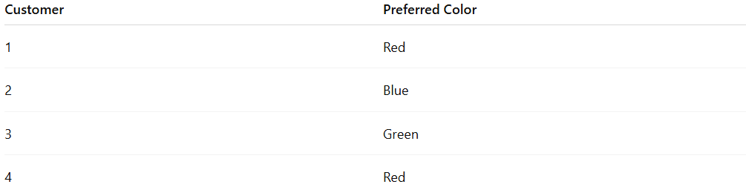
Customer | Preferred Color
1 | Red
2 | Blue
3 | Green
4 | Red
After Label Encoding:
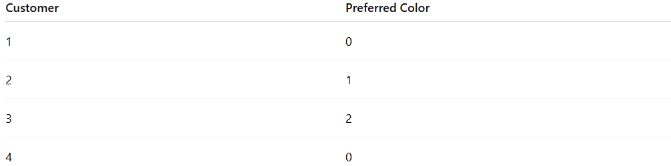
Customer | Preferred Color
1 | 0
2 | 1
3 | 2
4 | 0

Advantages
# Source: AI Source: Provided by: [Data Path: Persons Table -> ID Column: 1, Name_En Column: Motasem Essam] -> From: [Chatgpt (GPT‑5 Mini)] on [12/10/2025]
- Simple and easy to implement
- Requires less memory compared to other encoding methods
- Works well when categories have a natural order

Disadvantages
# Source: AI Source: Provided by: [Data Path: Persons Table -> ID Column: 1, Name_En Column: Motasem Essam] -> From: [Chatgpt (GPT‑5 Mini)] on [12/10/2025]
- May create false relationships between categories
- Algorithms may assume ordinal meaning between numbers even when none exists
- Not ideal for nominal categorical variables

Example in a Retail Dataset
# Source: AI Source: Provided by: [Data Path: Persons Table -> ID Column: 1, Name_En Column: Motasem Essam] -> From: [Chatgpt (GPT‑5 Mini)] on [12/10/2025]
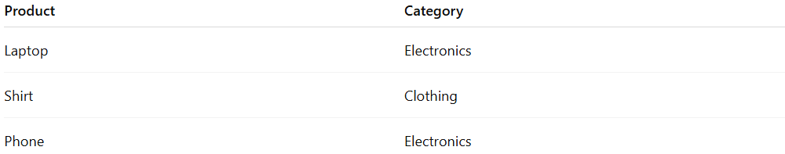
Product | Category
Laptop | Electronics
Shirt | Clothing
Phone | Electronics
After Label Encoding:
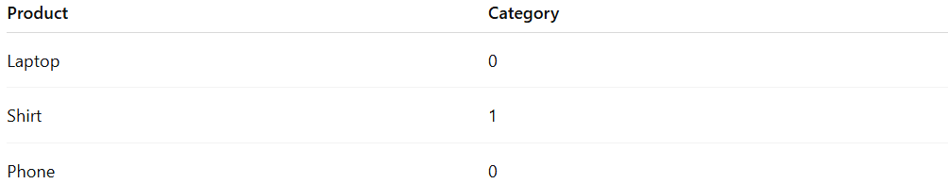
Product | Category
Laptop | 0
Shirt | 1
Phone | 0

